Task 2: Create Virtual Network with Subnets
What to do:
Create a Virtual Network with the following configuration:
Setting | Value
Address space | 10.0.0.0/16
Subnet 1 | WebSubnet — 10.0.1.0/24
Subnet 2 | AppSubnet — 10.0.2.0/24
Subnet 3 | DataSubnet — 10.0.3.0/24
Acceptance Criteria:
- VNet shows address space 10.0.0.0/16
- All 3 subnets are visible with correct address ranges
- No overlapping address ranges

Create a virtual network
- In the search box at the top of the portal, enter Virtual network. Select Virtual networks in the search results.
- Select + Create.
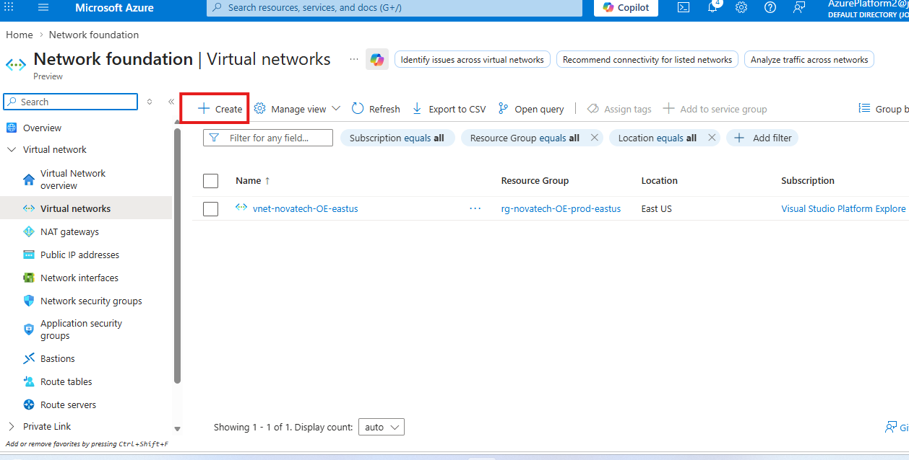

- On the Basics tab of Create virtual network, enter, or select the following information:
Enter the following values:
- Subscription: Select your Azure subscription.
- Resource Group: Select the previously created RG
- Virtual network name: Give the virtual network a name.
- Region: Select an Azure location East US

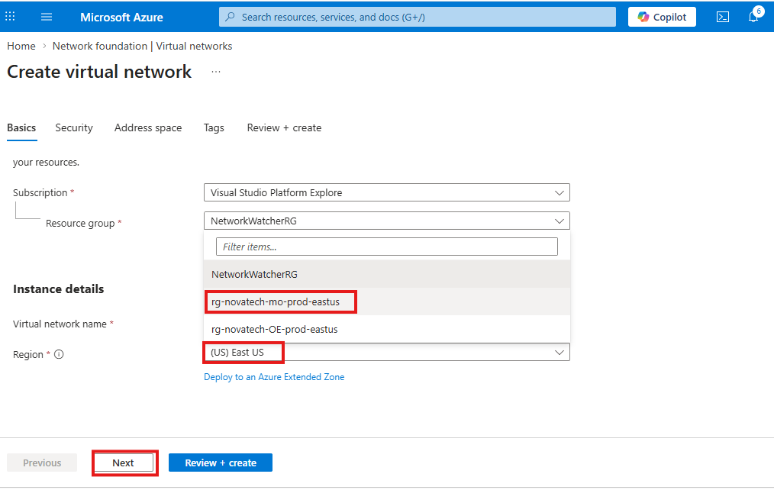
- Select Next to proceed to the Security tab.

- Select Next to proceed to the IP Address Space tab.
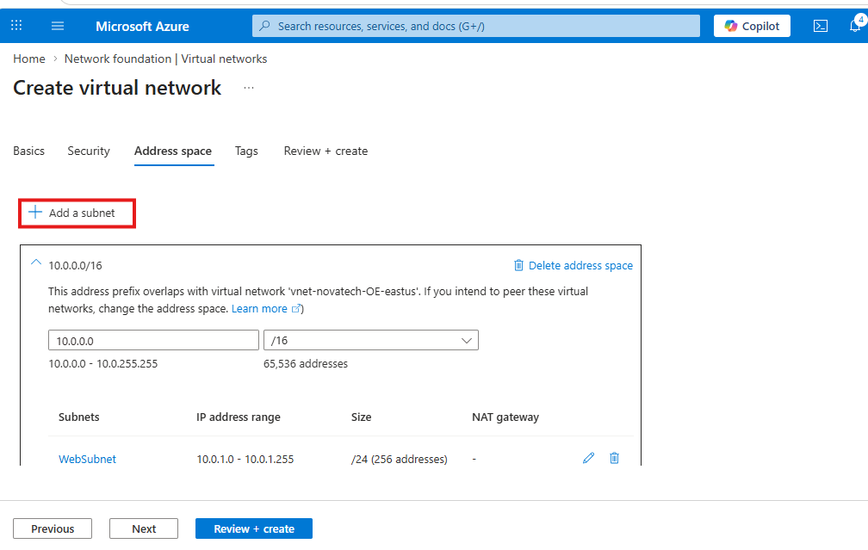

- In the address space box in Subnets, Edit the subnets.
WebSubnet: 10.0.1.0/24
AppSubnet: 10.0.2.0/24
DataSubnet: 10.0.3.0/24
